Given the list of processes, their CPU burst times, arrival times and priorities. Implement FCFS, SJF, Priority and Round robin process scheduling algorithms on the processes with preemption. For each of the scheduling policies, compute and print current task in each time step, the average waiting time and average turnaround time.

Waiting time: Processes need to wait in the process queue before execution starts and in execution while get preempted.

Turnaround time: Time elapsed by each process to get completely served. (Difference between submission time and completion time).

**FCFS Scheduling:**

Here the processes are arranged in order of their increasing arrival time. Check for incoming processes after the completion of the current process.

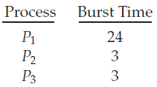

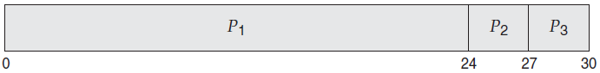

**SJF Scheduling:**

Check for incoming processes after every time step (1 ms).

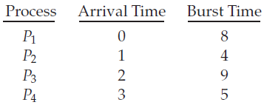

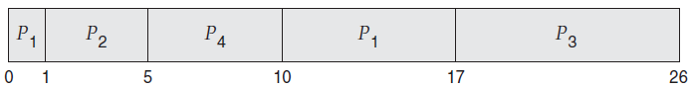

**Priority Scheduling:**

Check for incoming processes after every time step (1 ms).

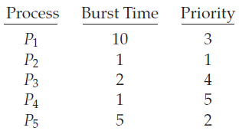

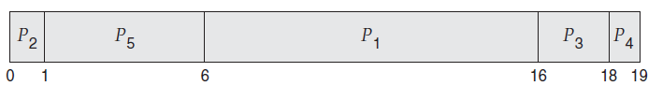

**Round-Robin Scheduling:**

Time Quantum = 4 ms

Check for incoming processes after every time quantum (4 ms).

